Jarrod Venter

STB16JV9306045062082  
MCSD C# FINAL APPLICATION

User Manual

CTUCare Applicaton



Contents

Splash Screen 3

Login 3

Home 4

Add User 5

History 6

Accounts 7

Information 8

Appointments 8

New Appointment 9

Open Appointments 10

New Patient 11

New Procedure 12

New Medicine 12

New Doctor 13

New Medical Aid Company 13

# Splash Screen



This is the first screen the user will see when launching the application. It will load for two seconds and then proceed to the login window. There are no intractable features on this window.

# Login

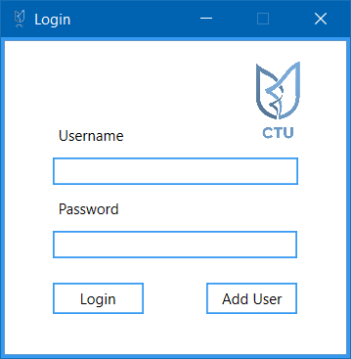

The login window is the 2nd screen in the application. To login one must enter their username in the username field as well as their password in the password field and click the login button. If you are a new user, please click the add user button to add a profile for yourself

# Home

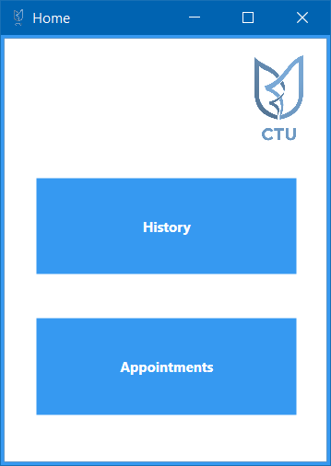

If your login is successful, you will proceed to the home screen where you will be given the option between viewing closed hospital cases (where the patient is no longer in the hospital) by clicking the history button or you can generate/edit appointments by clicking the appointment button

# Add User

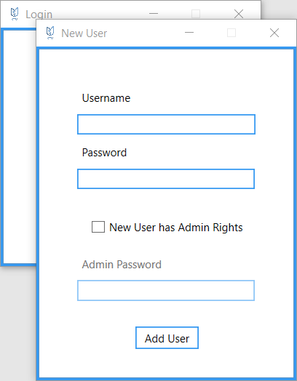

Checkbox

If you are a new user looking to get added at the login screen, this is the screen that appears when clicking add user. Enter you desired username and password in the fields. If you are going to be an admin user, check the checkbox and supply an admin password from an existing admin user. Once all enabled fields are completed, please click add user and proceed to the login page again where you can enter your new details to log in

# History

Back Button

List

Combobox

Search Bar

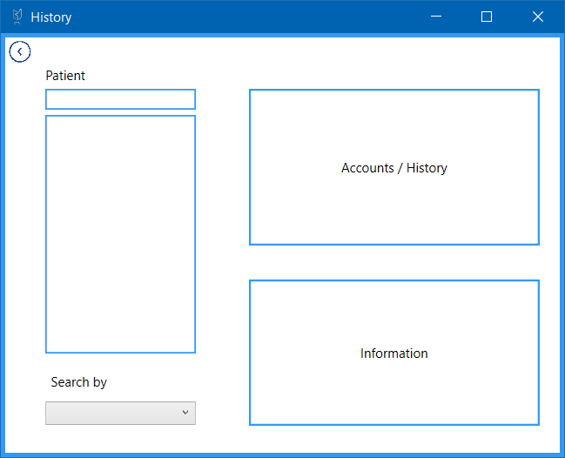

If you clicked the history button on the home page, you will have the option to view account/statement information as well as patient information on this page. To begin searching for a specific patient, click the combobox to determine how you would like to search the patient and then type your search query into the searchbar.

Once you have selected a patient which will appear in the list, click the accounts / history button to view previous hospital visit information as well as statements for the patient. To view patient information, click the information button.

Click the back button to go back to home

# Accounts

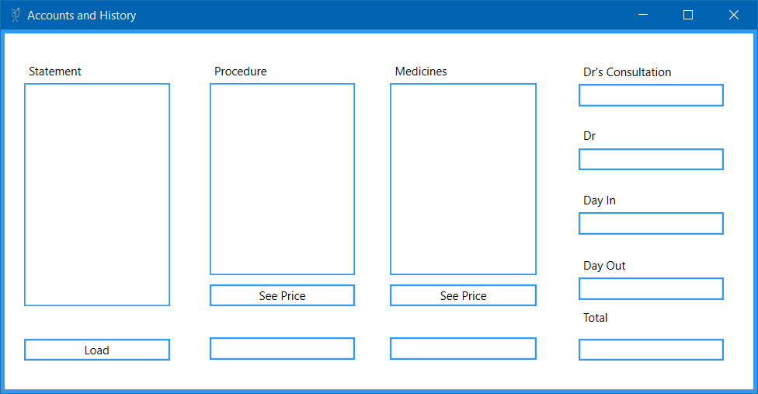

Medicine list

Procedure list

Statement list

If the patient that you searched in the history window any closed appointments they will appear in the statement list. To view information about a particular hospital visit, click the visit in the statement list and click load. Administered procedures, medicines, the doctor and his consultation fee, the patient’s day in and out as well as total price for that visit will appear. To view individual prices for medicines and procedures, click the item in the relevant list and click the corresponding see price button

# Information

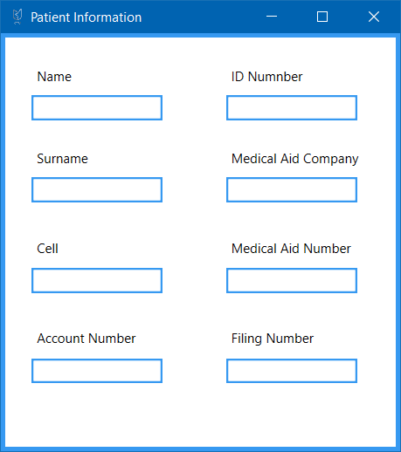

If you clicked information on the history window, the selected patients information will be displayed. Admin users will see more information that other users

# Appointments

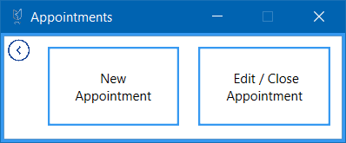

If you clicked appointments from the home window, you will be navigated to this window. The back button functions the same as other back buttons throughout the application and will always take you back to the previous screen (in this case home).

To generate a new appointment, click the new appointment button or to edit / close and existing appointment, click the button

# New Appointment

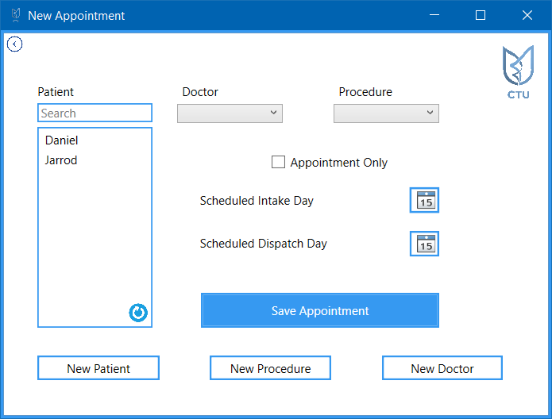

Refresh

Patient list

If you clicked the new appointment button on the appointment screen, you will be redirected to this window.

In order to save a new patient, you will need to have selected them in the patient list (you can search as well), selected a doctor and procedure (using the comboboxes), chosen an intake day as well as dispatch day (except when appointment only is checked).

You can add patients, procedures and doctors if you wish. To refresh the patient list after adding a new patient, simply click refresh, doctors and procedures will update automatically

# Open Appointments

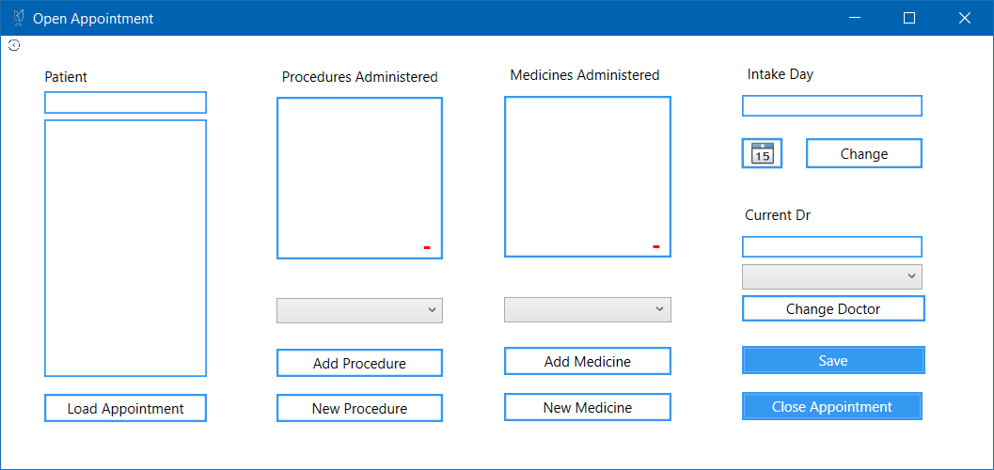

Similarly to the accounts window, appointments will only appear in the patient list if the patient has not checked out yet.

To load a current appointment and to see all of the details, select an appointment in the patient list and click the load statement button. You can add new types of procedures and medicines to the corresponding comboboxes. To add them to a current list of medicines and procedures, select the item in the combobox and click either add procedure or add medicine. The intake date can be changed similarly by selecting a new date and clicking the change button. The same can be done using the combobox for the doctor

To save all the changes, click save and if the patient is checking out, click the close appointment button and you will be taken back to the appointment screen

# New Patient

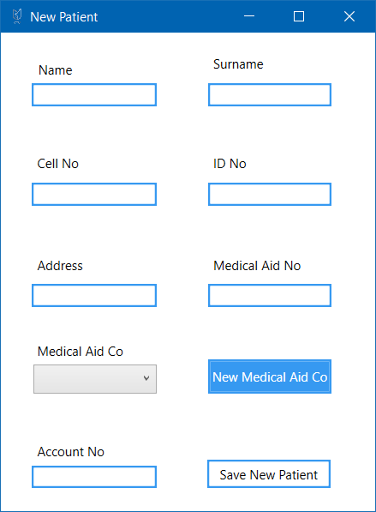

When adding a new patient from anywhere in the application, please enter the details into the fields with corresponding labels.

Medical aid can be selected using the combobox new medical aids can be added by clicking the button. Once all the fields are completed, click the save new patient button

# New Procedure

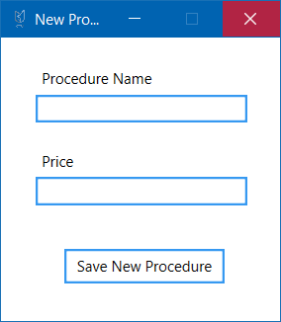

To add a new procedure, enter the name and price of the procedure into the correct fields and click the save new procedure button

# New Medicine

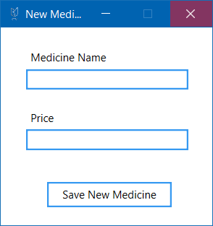

To add a new medicine, enter the name and price of the medicine into the correct fields and click the save new medicine button

# New Doctor

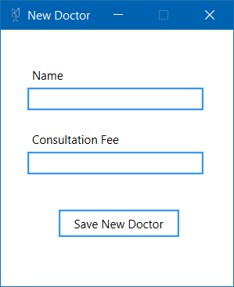

To add a new doctor, enter the doctor’s name and consultation fee into the correct fields and click the save new doctor button

# New Medical Aid Company

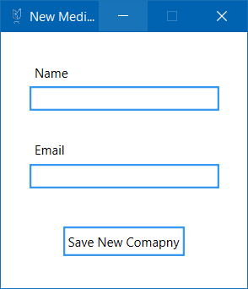

To add a new medical aid company, enter the name and email address into the correct fields and click the save new company button